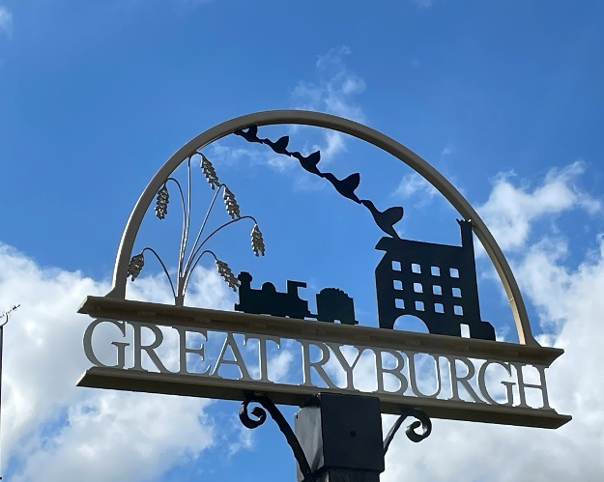
RYBURGH
PARISH COUNCIL
ANNUAL PARISH COUNCIL MEETING
MINUTES
TUESDAY 9TH MAY 2023
Minutes are draft until approved at a subsequent meeting.

CONTACT THE COUNCIL – ryburghpc@gmail.com 07506481841

Present: Cllr E Savory, Cllr N Dandy, Cllr J Binstead, Cllr I Wilson, Cllr H Plattin, Cllr J Savory, Cllr A James, Cllr C Buxton

- The Election of the Chairman. Cllr Binstead proposed Cllr Elizabeth Savory, seconded by Cllr Plattin.
- The Chairman’s Acceptance of Office. Cllr Savory indicated her acceptance of office and was duly elected.
- The Election of the Vice Chairman . Cllr E Savory (Chairman) proposed Cllr Neil Dandy, seconded by Cllr A James.
- The Vice Chairman’s Acceptance of Office Cllr Dandy indicated his acceptance of office and was duly elected.
- Apologies for Absence None
- The Council Members Acceptance of Office. All members completed their Acceptance of Office documents, duly signed and counter-signed by the Clerk/RFO.

Great Ryburgh Fuel Allotment Charity
- To Receive a report from The Great Ryburgh Fuel Allotment Charity. The retiring Trustees did not attend the meeting. Members deferred the matter until June. The Clerk was asked to contact the Trustees to ask them to submit a report and attend the June meeting.
- To appoint Trustees to The Great Rybrgh Fuel Allotment Charity. None present

Little Ryburgh Fuel Allotment Charity
- To Receive a report from Little Ryburgh Allotment Charity. A comprehensive report and accounts were received from Chris Hobson (Treasurer). The report will be made available on the Parish Council website.
- To appoint Trustees to the Little Ryburgh Fuel Allotment 2023 -2027. The following Trustees were elected: Terry Yarham (Chairman) Chris Hobson (Treasurer) Michelle Yarham (Secretary), Henry Palmer, Sue Murfitt, Reverend Stapleford (ex officio). Proposed by Cllr Dandy (Vice Chairman), seconded by Cllr James. Members thanked the Trustees for their work over the last four years. The Trust is a well organised and functioning charity and works effectively to meet the objectives laid out in the original Trust document.

- DONATION REQUESTS – Parish Groups/Committees/Charities
If you wish to request a donation, please supply the Clerk with details and Accounts AT LEAST TWO DAYS before the meeting.
The Village Hall/Playing Field Committee informed the members that, due to the very hot weather in the summer of 2022, they had not used all of the donation granted last year and asked that they may be allowed the retain the unspent amount (£843) Cllr Binstead proposed that they should retain the funds and this was seconded by Cllr James, and approved. The report from the Village Hall was read out during the Parish Meeting and will be made available on the Parish Council website.
The Village asked the Parish Council to nominate a Member to serve on the Village Hall Committee, Members unanimously voted for Cllr Dandy, who accepted the post.

- Confirmation of the accuracy of the minutes for the Parish Council Meeting, held on 4th April 2023. Approved. Proposed by Cllr Wilson, seconded by Cllr Plattin.
- To review the Parish Council Code of Conduct. Considered and approved. Proposed by Cllr James and seconded by Cllr Dandy.
- To review the Council’s Standing Orders Considered and approved. Proposed by Cllr Binstead, seconded by Cllr James.
- To receive a proposal to review all other Parish Council Governance documents over the next 11 months. Proposed by Cllr Wilson, seconded by Cllr Dandy, and approved.

FINANCE AND GOVERNANCE
- To consider the Insurance quote for 2023 -24 (previously circulated) Proposed by Cllr J Savory, seconded by Cllr Binstead and approved.
- To consider the NALC subscription for 2023 – 24 Proposed by Cllr Dandy (Vice Chairman), seconded by Cllr Binstead and approved.
- To consider the receipts and payments for April 2023 . Deferred until the June Meeting
- To receive a proposal to allow the Clerk to continue to make payments in accordance with the Budget for 2022- 2023 (all payments made by the Clerk will be authorised by an approved signatory) Proposed by Cllr Binstead, seconded by Cllr James. Approved
- To receive a proposal to add another Member to the list of Bank Signatories. Cllr J Savory proposed that Cllr Dandy (Vice Chairman) should become the third signatory, seconded by Cllr Plattin and approved.
- To receive an update from the Clerk about the Internal Audit. The Clerk informed the meeting the audit was not yet completed.
- To confirm that legal duties required by the Pension Regulator have been met – The Clerk. The Clerk explained the process and that the work would be completed by the end of May.
- To consider a proposal to produce a document, made up of the village reports for delivery to each household. After consideration it was agreed that the Clerk would contact the organisations who had submitted reports to ask if they would like to take part in the newsletter. The newsletter will consist of 5 or 6 lines and a reference to the full report on the Parish Council website. The Clerk will contact the organisations to evaluate interest, and if sufficient, quotes will be sought. Proposed by Cllr Wilson and seconded by Cllr Buxton.

UPDATE ON ITEMS FROM THE PREVIOUS MINUTES
- Dog Fouling Poster – Cllr Wilson. Cllr Wilson said he had not yet moved the dog fouling poster, but it will be moved very soon.
- Assets – Cllr Dandy (Vice Chairman) gave the meeting an update on the village asset maintenance programme. Agreed works for 2023 are underway. Cllr Dandy reported on the blocked gullies in Gately, now repaired.

PLANNING
- To receive updates and new planning applications. No applications have been received.
- To receive an update on the Crisp Maltings Development (If available). No further information at this time.

NEW ITEMS FOR CONSIDERATION
- To consider the correspondence from the Campaign Against New Town (CANT). After consideration Members agreed to support the Campaign, Cllr Wilson proposed and Cllr E Savory (Chairman) seconded. The Clerk was asked to respond accordingly.
- Items that have arisen after the publication of the agenda – for information only. Cllr E Savory (Chairman) thanked Cllr Jane O’Leary for her contribution to the Parish Council and the Community. Cllr O’Leary has not sought re-election. Cllr Dandy (Vice-Chairman) reported that a teenager is riding an electric scooter through the village and this is of concern to residents. Members asked the Clerk to report the matter to the Police.
Cllr J Savory raised the issue of visibility at the junction from Ryburgh onto the A1067. Cllr Savory said the hatchings are creating an area whereby traffic moves onto them to pass slower moving traffic but cannot be seen by cars waiting to turn onto the A1067 from Ryburgh. The Clerk was asked to contact Cllr Aquerone to propose a meeting with Cllr Savory. Cllr plattin asked the Clerk to remind Highways to cut the grass on both sides of the road at Hillcrest.
- The confirm date of the next Parish Council Meeting (27th June at 7.30pm) and Parish Council meeting dates for the rest of the year. (previously circulated).
- To close the meeting. There being no further business the Chairman closed the meeting at 8.55pm

