Minutes of Meeting
24.05.2022 in Memorial Hall, Annex at 19.30
Present:
K.Wilson
J.Binstead
J.O’Leary
J.Savory
N.Dandy
M.Rundle
Apologies for Absence:
E.Savory, I.Wilson, H.Platten
This meeting held in order to agree and finalise the updated Parish Council objection to the 2 No Crisp Applications, all as follows: -
_______________________
Our response to planning applications PF/20/0523 and PO/20/0524 as updated by Crisp in January 2022.
We objected on 18 June 2020 and 11 March 2021 to the Applications as originally drafted.
Since our last Objection, we now refer to recent data as follows:
- New Environment documents ref: 02.02.22, 08.04.22 and App 1.1aa.
- Revised Highways ref: 08.12.2021
We continue to confirm our objections to both applications remain and state the following: -.
- We do not believe the amendments materially alter the substance of the previous applications, and therefore we remain opposed to both as now submitted.
- We are disappointed that the Crisp amendments have not addressed or resolved the Objections arising from their Applications to date.
- The Crisp proposals are not compliant with the Existing Plan, the Emerging Plan, the National Planning Policy Framework, or the Ryburgh Neighbourhood Development Plan (NDP) which is now formally approved by NNDC and strongly supported by the village community.
- NCC Highways have highlighted, in very clear terms, their opposition to plans that would result in more than 50% additional Crisp HGV traffic in Great Ryburgh.
The proposals will increase the annual quantity of malt by 52% from 115 to 175 thousand tonnes each year. This will significantly raise the following additional HGV traffic safety risks and hazards to all in Great Ryburgh: -
  - There is no passing provision in Station and Fakenham Road.
HGV’s have to drive on both footpaths placing all pedestrians, parents with pushchairs and children at risk as they have nowhere to escape. You will know that Ryburgh is a classic Linear Village configuration – NCC Highways advice to NNDC dated 18.02.21 SHCR 07 refers.
  - Property damage and risk of traffic accidents
  - Traffic noise
  - Vibration
  - Fumes
  - Pollution – particularly the River Wensum SSSI and SAC.
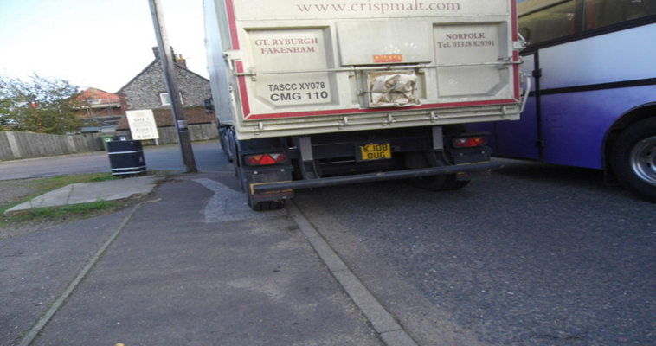
Photograph shows a Crisp Maltings HGV passing a stationary School Bus collecting pupils.

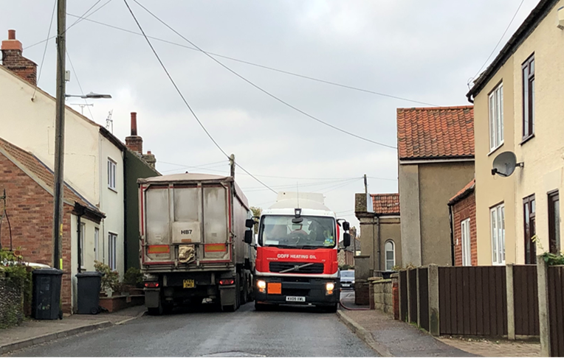

- We believe that these Crisp plans also contain a provision to operate on a regular 24 hour working cycle and certainly represent no community benefit and in fact would reduce this village into an industrial zone, solely to the benefit of Crisp.
- As to the Crisp revised proposals, we have the following specific comments: -
  - Landscaping
    - The ecological surveys are inadequate and miss several important species, e.g., great crested newts, slow worms and bats.
    - The planting mitigation measures are insufficient and there will be a net loss of key habitat and landscape character.
This is contrary to NNDC Core Strategy EN2 and the Ryburgh Neighbourhood Development Plan, Policies 4 and 9.
    - Loss of valuable semi-improved grassland is ignored.
    - There is no Construction Environmental Management Plan to be applied, which would ensure that the planting mitigation and its aftercare is properly carried out.
  - Warehouse
    - The massive proposed new warehouse would loom over numerous nearby houses on Fakenham Road and will not be screened for at least 15 years, even if the planting is well cared for (see 6 aiii above).
    - In addition, the outline application allows for any building infrastructure up to 20 meters high, plus roof top plant and additional lighting etc. across the whole 8-acre site. This data is set out in Crisp drawing No 12.4A dated 23.11.20 titled, “Cross-section thru’ the Warehouse and Fakenham Road”.
    - Further, the current Crisp plan seems to enable this warehouse to be executed prior to any completion of the new relief road. This arrangement will result in a chaotic combination of local traffic clashing with Crisp service HGV’s and construction traffic all simultaneously using the single narrow Fakenham and Station Road for a period likely to exceed 24 months.
  - Highfield Lane/ New Access Road
    - The Crisp plans contain no information on how the existing farming infrastructure, with sole access via Highfield Lane, is to continue operating when the New Access Road is being constructed and later in use.
    - We do not believe that a private road should have priority over Highfield Lane.

  - Widening of Fakenham Road
    - This will result in the loss of important hedgerows and mature trees. This risk is not mentioned in the proposals – trees are not even marked on the Crisp plans.
  - Ground Water Protection Zone (GWPZ)
    - The applications are in breach, and would adversely affect, the GWPZ.
  - Flood Risk
    - The Crisp applications identify that the planned works increase the current risk level of flooding for the site and village environment.
    - Flooding is also highlighted where the New Road crosses Highfield Lane.

  - TRO
    - Crisp suggest that they will…. “Contribute towards TRO”.
It is not clear what form that “contribution” would take.
- We have given the TRO proposal careful consideration and taken into account the views expressed by the Highways Authority in their letter ref. 9/1/20/0524 & 9/1/20/0523 dated 18.02.2021.
We would welcome the introduction of the noted TRO’s, but only in the circumstances whereby the construction of the new Access Road is completed, and a TRO, banning all HGV’s from using the bridge over the River Wensum, is in force before any Crisp application related works commence.
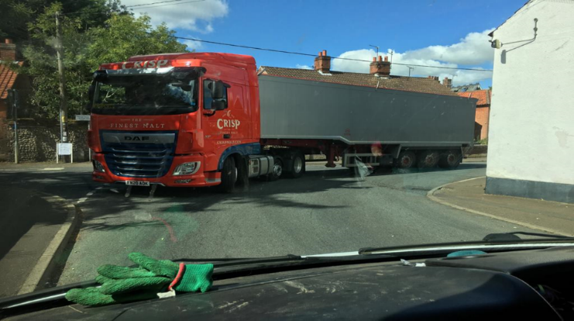
- We also wholeheartedly support the Highways Authority’s conclusion that PF/20/0523 should be refused unless the stated TRO disciplines are applied by Crisp because of the additional 52% HGV traffic it would generate and the consequent danger to highway safety in the village.
It is a concern that Crisp appear unable to future control the routing of increased volume of HGV’s and factory vehicles within the village. This would risk the continued use of 3 separate vehicle access/exit gateways in the middle of the village, even when/if the new relief road may be built or ever used.
- We would expect any Planning Permission in respect of these Applications to be in keeping with NNDC Policy CT5 and Ryburgh Neighbourhood Development Plan Policy 1 and all current national Environmental Protection legislation.

- We acknowledge and appreciate the difficult issues the NNDC Planning Committee and Highways have faced as they deal with the Crisp Applications particularly concerning environmental protection and public safety challenges over a number of years.
- In conclusion, we see the situation resting between two completely different outcomes:
  - To permit continuing development of the industrial complex in the village and all the irreversible consequential damage to the River Wensum, its Valley terrain and the village population.
Or,
  - A decision that the current industrial complex will not be allowed to grow any more and further overwhelm Great Ryburgh, and therefore protect the River Wensum, its Valley, surrounding countryside and the people living in Ryburgh.
Dated 24 May 2022

